Pattern Problems
class Main {

public static void rectangle(int row , int col){
for(int i = 1 ; i<=row; i++){
for(int j = 1; j<=col; j++){
if(i == 1 || i == row || j==1 || j==col){
System.out.print("*");
}else{
System.out.print(" ");
}
}
System.out.println();
}
}

public static void main(String[] args) {
rectangle(4,5);
}
}

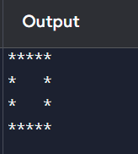

class Main {

public static void pattern(int n){
//line
for(int i=1; i<=n; i++){
//spaces
for(int j=1; j<=4-i; j++){
System.out.print(" ");
}
//star
for(int k=1; k<=i; k++){
System.out.print("*");
}
System.out.println();
}
}

public static void main(String[] args) {
pattern(4);
}
}

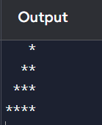

class Main {

public static void pattern(int n){
//line
for(int i=1; i<=n; i++){
for(int j=1; j<=5-i+1; j++){
System.out.print(j);
System.out.print(" ");
}
System.out.println();

}
}

public static void main(String[] args) {
pattern(5);
}
}

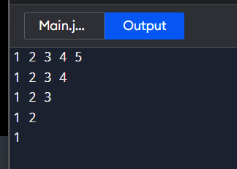

class Main {

public static void pattern(int n){

int counter = 1;
//line
for(int i=1; i<=n; i++){
//counter
for(int j=1; j<=i; j++){
System.out.print(counter);
System.out.print(" ");
counter++;
}
//space
for(int k=1; k<=n-i+1; k++){
System.out.print(" ");
}
System.out.println();
}
}

public static void main(String[] args) {
pattern(5);
}
}
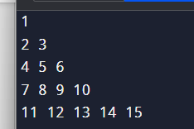
class Main {

public static void pattern(int n){
for(int i=1; i<=n; i++){
for(int j=1; j<=i; j++){
if((i+j) % 2 ==0){
System.out.print("1");
}else{
System.out.print("0");
}
}
System.out.println();
}
}

public static void main(String[] args) {
pattern(5);
}
}

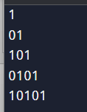

class Main {

public static void pattern(int n){

// part 01
for(int i = 1; i<=n; i++){
//star
for(int j=1; j<=i; j++){
System.out.print("*");
}
for(int j=1; j<=2*(n-i); j++){
System.out.print(" ");
}
for(int j=1; j<=i; j++){
System.out.print("*");
}
System.out.println();
}

//part 02

for(int i = n; i>=1; i--){
//star
for(int j=1; j<=i; j++){
System.out.print("*");
}
for(int j=1; j<=2*(n-i); j++){
System.out.print(" ");
}
for(int j=1; j<=i; j++){
System.out.print("*");
}
System.out.println();
}
}
public static void main(String[] args) {
pattern(4);
}
}

